Some portuguese traditions

CARETO
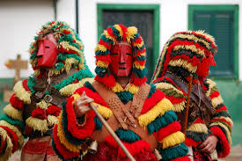
The Careto tradition is a pre-historical Celtic religious ritual still practised in some regions of Portugal, namely in the villages of Podence (Macedo de Cavaleiros, Bragança District) and Lazarim (Lamego, Viseu District). It currently takes place during Carnivaland is one of the oldest traditions being practiced in Portugal today.
Caretos are masked young men dressed in suits made of yellow, red, black, blue and green fringe wool quilts, wearing brass, leather or wooden masks and rattles in their belts.
Cartetos in the Carnival at Lazarim
Shrove Tuesday and the prior Sunday are the days when the Caretos are most active. They appear in groups from every corner of the village running and shouting excitedly, frightening the people and “robbing” all the wineries.
The main target of these masquerade groups are single young girls, who make them climb to the top of walls and verandas.
Scholars associate the Careto tradition with memories of magical practices related to agrarian fertility cults.

Coimbra’s students big serenade

In May, during the university festivities for the ones who complete their degrees, on the stair of Old Coimbra Cathedral, studens sing the “fado” of Coimbra.

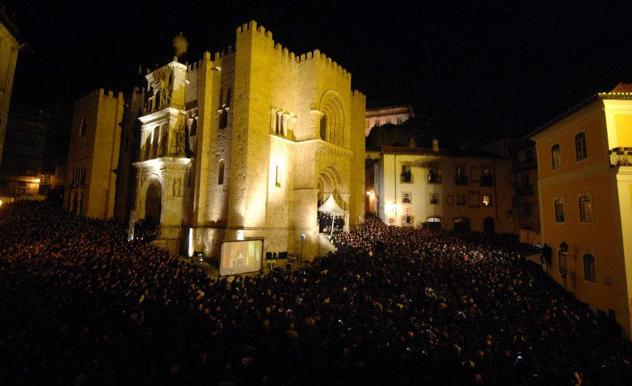

Popular saints in June

Mainly St Anthony in Lisbon, on the 13th.
Big neighbourhods festivities all over the city with food and music. On the nigh of the 12th, on the main avenue in Lisbon, there is a big parade of popular marches. Each neighbourhood chooses a theme and a song and they compete among themselves.

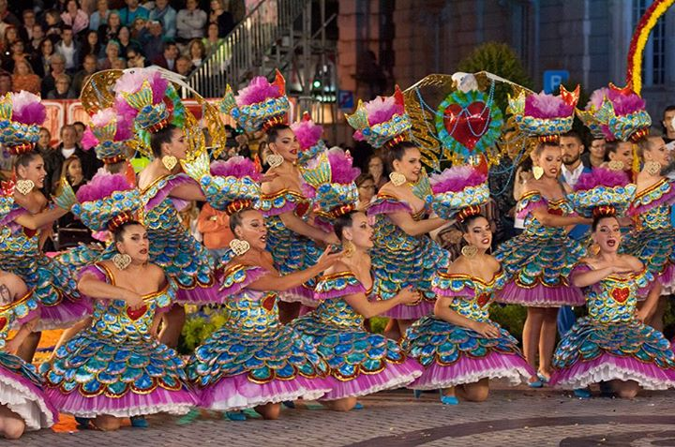

Trays Festival in Tomar
Every four years, hundreds of people parse 5 km in the city. The girls carry their trays on their heads. It is a festivity in honour of the Holy Spirit and dates back from the 13th century.

Popular streets in the city centre are decorated with millions of paper flowers.

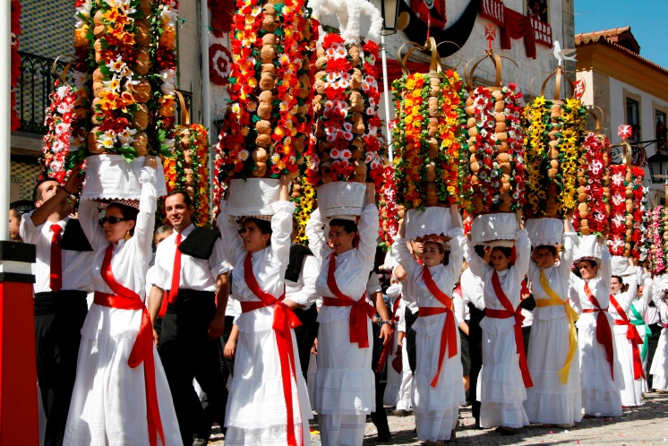
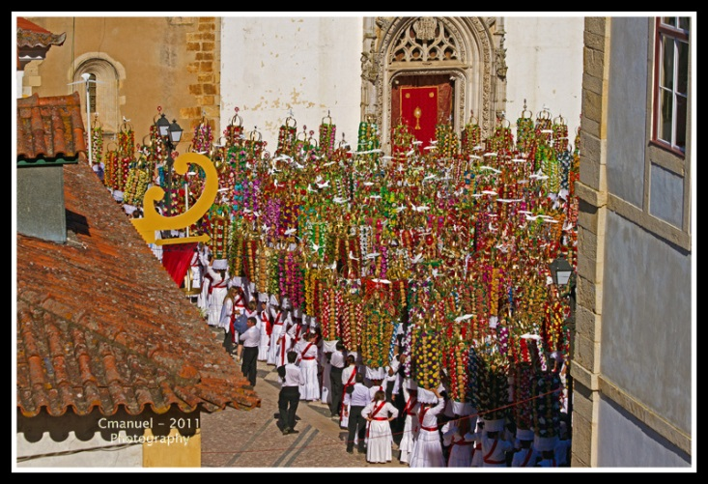
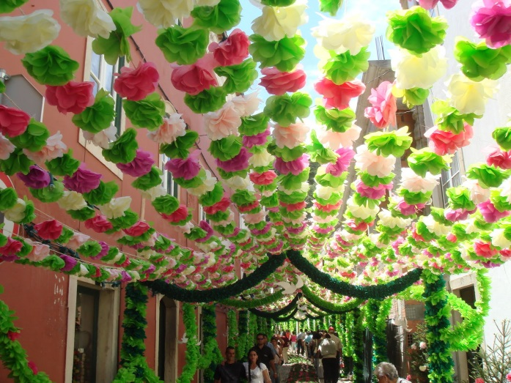

The ” Maios “

In the Algarve region, in May, straw male and female puppets representing adult people are placed on the streets in facing the houses as social criticism or representing everyday life scenes.

